EC2
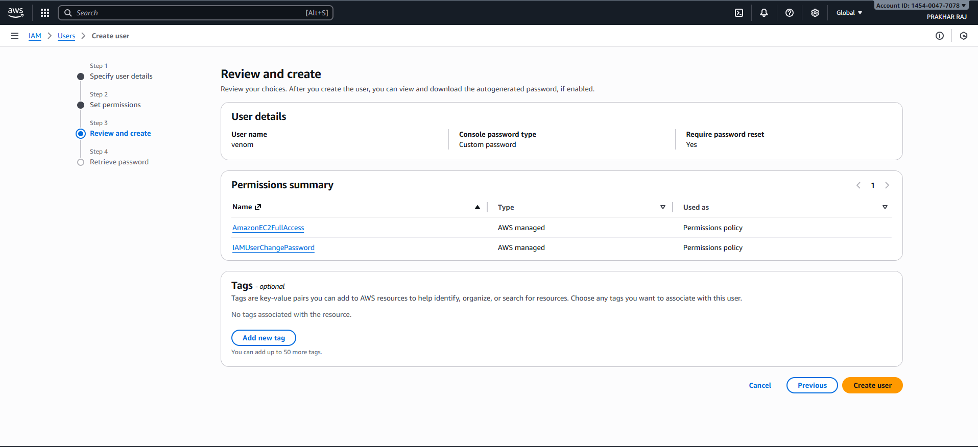
AWS IAM – Review & Create User Summary
User Name: venom
Console Password Type: Custom password
Require Password Reset on First Login: ✅ Yes
Assigned Permissions:
- AmazonEC2FullAccess (AWS managed policy)
- IAMUserChangePassword (AWS managed policy)
Tags:
- No tags currently associated
- Option available to add up to 50 tags
Next Step:
- Proceed to create the user and retrieve the autogenerated password
Region Context: Asia Pacific (Mumbai)
Would you like this added to your AWS workflow documentation alongside the SNS and Lambda summaries? I can also help you format it for client onboarding or internal SOPs.
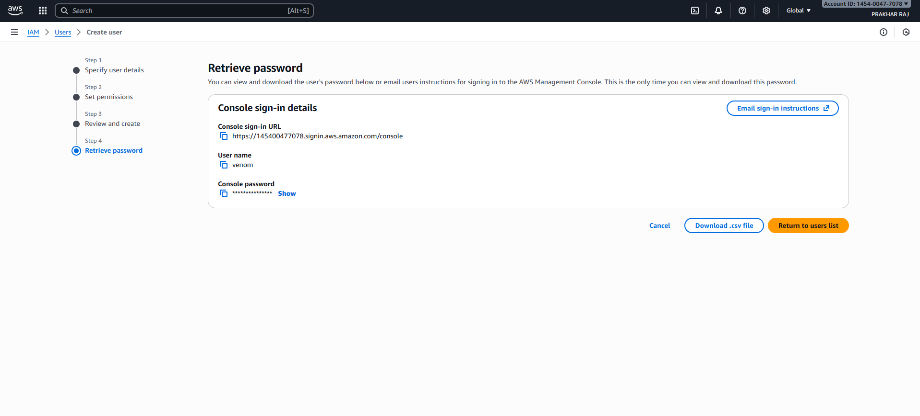
AWS IAM – User Credential Summary for venom
Console Sign-in Details:
- Sign-in URL: https://145400477078.signin.aws.amazon.com/console
- User Name: venom
- Console Password: (hidden, retrievable)
Available Actions:
- Email sign-in instructions
- Download credentials as .csv
- Return to users list
- Cancel
Region Context: Asia Pacific (Mumbai)
Account ID: 145400477078

